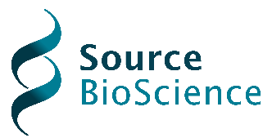
Social Value Statement 2026
The organisation is committed to delivering measurable and sustainable social value through the delivery of all call-off contracts, with particular emphasis on environmental responsibility, operational efficiency, and alignment with public sector net zero objectives.

We maintain a Carbon Reduction Plan compliant with PPN 06/21 and the GHG Protocol Corporate Accounting and Reporting Standard and are committed to achieving Net Zero emissions by 2050. Demonstrating this commitment, we have achieved a substantial reduction in greenhouse gas emissions from 1,001.10 tCO₂e (2022 baseline) to 202.01 tCO₂e in 2024, representing a reduction of approximately 80%.

We have also delivered significant improvements in energy efficiency, reducing total energy consumption from 3,467,425 kWh in 2023 to 984,273 kWh in 2024. These outcomes have been achieved through targeted initiatives, including the adoption of digital processes, optimisation of operational assets, and ongoing monitoring of energy usage.

In the context of call-off contracts, we will deliver social value through:
- Continued reduction of carbon emissions and energy consumption associated with service delivery
- Embedding digital and efficient working practices to minimise environmental impact
- Transparent monitoring and reporting of environmental performance
- Alignment with our Corporate Social Responsibility (CSR) commitments and continuous improvement strategy

These activities enable us to support contracting authorities in meeting their sustainability and net zero targets, while ensuring that social value outcomes are tangible, measurable, and continuously improved throughout the contract lifecycle.

